This is the way how I think and design the Curriculum Viate application:

I created ViewPaper which has 4 fragments: HomeFragment, AboutFragment, WorkFragment, ContactFragment.

I use Actionbar to display my name and qualification in MainActivity. So It is always visible and common for all the fragments.

**HomeFragment:**



It contains my image, nane, qualification, some information about me and my contact

By combining RelativeLayout, LinearLayout, TextView and ImageView, I create a layout as you can see abow.

**AboutFragment**



It contains my education info, describle about me.

**WorkFragment**

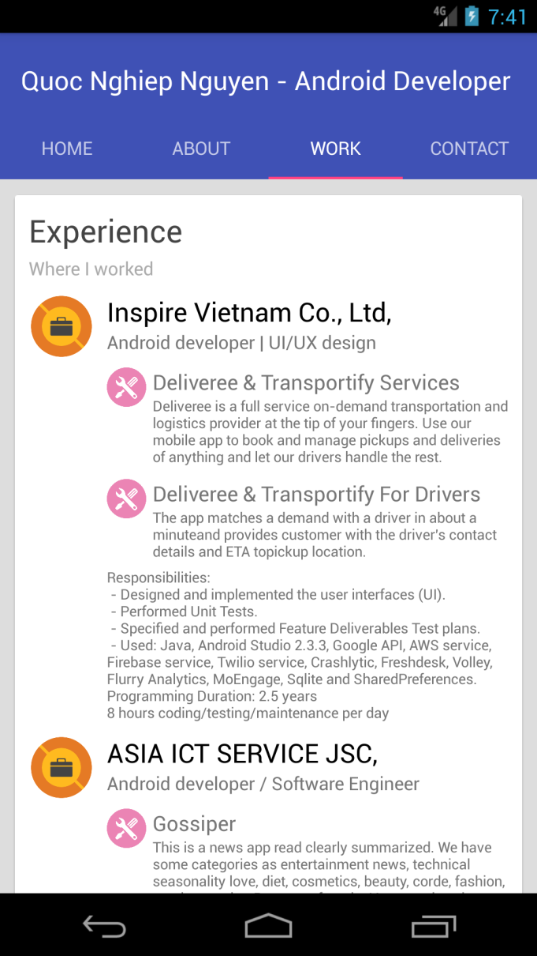

This screen show my working background, experiences, project informations.

**AboutFragment**



It show my contact: phone number, personal email, and my Facebook page